Application of the Business Model Canvas in Farm Management Education
Blake Brown¹, Paul Mugge² and Michelle Grainger², ¹Agricultural and Resource Economics, NC State University, ²Center for Innovation Management Studies, NC State University, Raleigh NC, U.S.A.; contact abbrown@ncsu.edu

Abstract
Traditional business planning most often implicitly assumes a static world and near perfect knowledge of the planning horizon. In today’s fast changing business world with seemingly continuous disruptive innovations, a dynamic, flexible and lean business model is needed. This includes agriculture. The business model canvas provides such a modeling tool. We present an application of the business model canvas to farm management education for large diverse farms. The dynamic, visual and tactile learning process with the business model canvas proves an excellent teaching medium for these large farms.
Key words: business model canvas, value proposition
Introduction
Change is a constant in agriculture; whether the change is due to rapidly changing technology or changing consumer tastes and preferences. While innovations occur throughout agriculture, diverse farming operations must navigate change across a number of enterprises. In the case of large scale commodities, such as corn and soybeans, innovation is very often propelled and even controlled by farm suppliers; e.g. the biotechnology revolution in the seed industry.
For specialty crops, innovations are more likely to originate and be propagated at the farm level. For example, in U.S. sweet potato production, producers still partner with land grant universities to develop new varieties (this used to be the model for many crops) or come up with innovations in harvesting equipment. On the consumer products side, many of the innovations in sweet potato products originate and are developed by farmers. For example Hams Farms along with a handful of other large producers developed and market an innovative vegetable and fruit puree using a patented industrial microwave process (.http://www.hamfarms.com/pages/yamco-vegetable-and-fruit-puree). Regardless of the source of change or the innovations associated with the change, farmers must be increasingly astute and nimble in order to profitably navigate change.
Given this environment of innovation and change is traditional business planning the best or even a realistic way to strategically navigate change? In the traditional business planning process the planner drafts a vision statement based on his vision of the future for his business, then an environmental scan is completed and a mission statement drafted. Then goals and objectives are formed followed by an action plan that includes detailed financial projections years into the future. Most experts in business planning suggest that the plan must be revisited and revised during implementation to reflect the inevitable realities of business discovered only via implementation and the changing environment in which the business operates. In reality, business plans are rarely done in farming operations and even more rarely revisited and revised. If business plans are done they are often developed as static plans that act like the dynamic world in which businesses operate is also static. Is there a better way? In their book Business Model Generation Osterwalder and Pigneur present the business model canvas as a better approach to modeling businesses in a business world where change and innovation occur at an increasingly rapid pace. We present an application of this approach in teaching farm management to large diverse, specialty crop farms.
Background and Method
A problem in conventional business planning is that it implicitly assumes that the business planner can figure out most of the unknowns as well as the future path of the business before the business even starts. Blank in his article “Why the Lean Start-Up Changes Everything” notes that “1. Business plans rarely survive first contact with customers.” and “2. No one besides venture capitalists and the late Soviet Union requires five year plans to forecast complete unknowns.” Blank’s article speaks to start-ups and the value of the lean method. One of the principles of the “lean method” according to Blank is to use the framework of the business model canvas. The business model canvas was conceived by Alexander Osterwalder. The canvas allows the business owner to test hypotheses (“basically, good guesses”) about their business idea. Farms are not usually start-ups, but they often start new enterprises and even in “old” enterprises disruptive technologies mean that acting like a start-up is a meaningful way to model the business.
The business model canvas (Figure 1) models the business in nine building blocks; four focused on the customer side of the business, Customer Segments, Customer Relationships, Channels, and Revenue Streams; four focused on the supply side of the business, Key Activities, Key Resources, Key Partners and Cost Structure, joined by a key block, the Value Proposition for the business. Completion of the customer blocks and the supply side blocks lead to the formation of a Value Proposition for the business i.e. the “bundle of benefits the company offers its customers” (Osterwalder and Pigneur, P. 22).
Figure 1. The Business Model Canvas
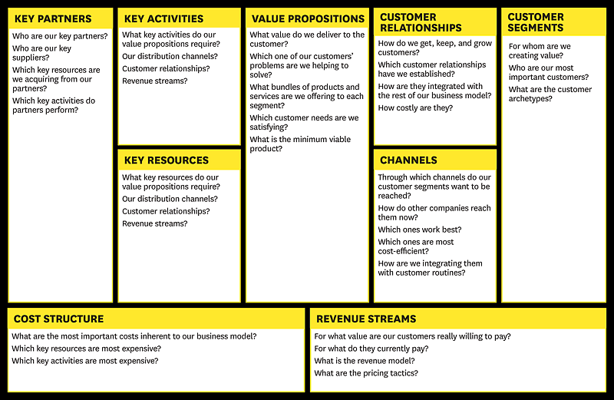
Source: www.businessmodelgeneration.com/canvas. Alexander Osterwalder and Yves Pigneur.
Formation of a Value Proposition may lead to changes in the other building blocks. For example Key Activities may have to be changed to accommodate a newly discovered Value Proposition. The process of using the Canvas ultimately leading to the Value Proposition, is dynamic, interactive, and visual and allows, even encourages, changes in the various building blocks during the process. From a teaching standpoint the visual, interactive, tactile process is an excellent environment for learning, especially for farmers.
Osterwalder and Pigneur in Business Model Generation (2010) show how to use the canvas with other business tools. For example, a section of the book is devoted to how to map an environmental scan into the canvas. The increasingly widespread use of the business model canvas has led to a proliferation of tools from many sources to use with or enhance the canvas. Emphasizing the importance of the Value Proposition, a Value Proposition Canvas is promoted as helping with Value Proposition Design for which there is also a book Value Proposition Design. Many resources for using the business model canvas can be found at www.strategyzer.com.
Farms gain management skills from a number of sources. Experience is certainly important. Many very large farmers hold college degrees; some have advanced degrees such as an MBA. Land grant universities have provided varying levels of farm management education. Most have focused on more traditional management skills; not necessarily the advanced skills needed by modern large farms. There are programs that address the growing segment of large farms, most notably TEPAP (The Executive Program for Agricultural Producers) at Texas A&M.
Application: The Executive Farm Management Program
The Executive Farm Management Program is a newly created program initiated by the Department of Agriculture and Resource Economics (ARE) in the College of Agriculture and Life Sciences at North Carolina State University (NCSU) in collaboration with the Center for Innovation Management Studies (CIMS) in the NCSU Poole College of Management and the College of Business at East Carolina University (ECU). The goal of the program is to strengthen core business competencies in large diverse farms, particularly those with specialty enterprises. (Our program could also be applied to small to mid-sized farms.) The idea for this program was conceived by a few large farmers in North Carolina who participated in TEPAP. While very complimentary of TEPAP, they communicated the need for a program focused on the specialized needs of farms in the southeast. Given the diversity of southeastern agriculture, designing one program to fit all types of southeastern farms would not accomplish the goal of meeting the needs of specialized farms. This led to the decision to design each program around the needs of a particular segment of farming. Offering executive education focused on a particular industry sector is not a new concept. For example, Duke University Fuqua School of Business offers executive education focused on the health care sector. Kellogg School of Management offers executive education for family businesses. Harvard Business School has its long standing Agribusiness Seminar. Of course most business schools also offer custom design of executive education for particular companies. In agriculture, Purdue’s Center for Food and Agricultural Business is very successful in designing and delivering custom programs to Agribusiness.
To compliment the goal of customization, the Executive Farm Management program is delivered via one intense week early in the year and one intense week near the end of the year. This allows customization not only to the segment of farming targeted by the particular program, but also to the class of farmers enrolled and their particular needs. The two one week long sessions are connected by a series of virtual sessions on topics of special interest to the class. Executive education programs like Columbia Business School’s Advanced Management Program 2X2 have successfully employed a similar approach of offering a two week face-to-face session followed by virtual sessions and then culminating in another two week session.
Given the rapidly changing and innovative business environment experienced by large farms, particularly the specialized farms of the southeast, the business model canvas is an appropriate tool for teaching strategic planning. The Center for Innovation Management Studies (CIMS) teaches strategic planning and management to numerous business clients combining their own unique approach to innovation management, described in their book, Traversing the Valley of Death (Markam & Mugge, 2015) along with the business model canvas. CIMS implements this approach in the Executive Farm Management Program.
The target audience for the pilot program of the Executive Farm Management Program is sweet potato and tobacco farms in North Carolina. North Carolina is the largest tobacco and sweet potato producing state in the U.S. growing over 50% of the nation’s tobacco and almost 60% of the nation’s sweet potatoes. The markets for the two crops could not be more different. Sweet potatoes are heralded for their great nutritional value. Demand is growing rapidly in the U.S. and abroad for sweet potatoes and a multitude of innovative sweet potato products. Tobacco product consumption has been declining for years. At the consumer level it is maligned and heavily regulated. While there are innovations in tobacco products, most of these will lower the amount of tobacco needed per product unit. Interestingly, tobacco still yields some of the greatest profits per acre of any crop grown in the southeast. Sweet potatoes are usually profitable and usually more profitable than field crops, but not as profitable as tobacco.
What the two crops do share in common is that both are very management and labor intensive. In addition, the labor requirements of the two crops are complementary. Most of the farms in this group are large. According to the 2012 Census of Agriculture, of the 1682 operations with tobacco acreage harvested, 471 were family farms with gross cash farm income of $1 million or greater.
The inaugural Executive Farm Management Program was promoted for implementation in 2017 and 21 farms were selected for the pilot program. The 21 farms grew 30,515 acres of sweet potatoes; 32% of the 95,000 acres grown in NC in 2016 and 19% of the 163,300 acres grown in the U.S. The 21 farms grew 10,760 acres of tobacco. They also produce large acreages of field crops such as soybeans and corn. Many grow other fresh vegetables and fruit and some have substantial contract production of poultry and hogs. One of the farms not only has all the mentioned crops and livestock but also has over 1200 beef cows. Gross cash farm income was reported by 17 farms. The four largest farms did not disclose their gross income. Of the 17 reporting, gross cash farm income averaged $5.8 million per farm. The 21 farms employed over 600 fulltime employees and almost 3,000 seasonal workers. Needless to say, these farms are very management and labor intensive.
Farms were selected for the program in January 2017 with the first session February 6-10. The final week of the program will be November 27-December 1, 2017. The core topics of the program are strategic planning, human resource management, financial management and family business issues (e.g. succession planning). In between the sessions, the class participates in a virtual session at least once each month. The topics for the virtual sessions range from commodity situation and outlook to tax management. CIMS provides leadership on strategic planning, ECU on HR and financial management, with ARE providing overall leadership, information and presentations on relevant agricultural topics, and leadership on development of a case study farm. The result is a very strong and productive collaborative program. The two one week sessions are held on the campus of NC State University.
In the weeks preceding the session the participants provided input to the development of a case study farm for use in teaching the components of the program. The case study farm grows 300 acres of tobacco, 400 acres of sweet potatoes and 3,000 acres of corn and soybeans. While the farm in the case study is smaller and less diverse than some of the participants’ farms, it looks very familiar to the class with many of the same challenges they face. The participation of the class in development of the case study ensures the case is relevant and invests the participants in the case. Many of the farms in the class know each other and are competitors. The case study provides a medium in which to practice what they are learning in the class with the benefits of group discussion and collaboration without having to reveal details about their own business.
During the first week session CIMS led the class in an environmental scan of the sweet potato and tobacco sectors using PESTEL that was in turn used in SWOT analysis. CIMS used IBM’s Watson in the PESTEL analysis. The class divided into five teams with each team working on a business canvas for the case study farm. Before working on the business canvas, each team developed their own PESTEL and SWOT Analysis for the case. Each team identified which PESTEL factors they thought were significant threats or opportunities to the case, the degree of importance of the factor, the urgency of the threat or opportunity presented by the factor and which building blocks of the business canvas they thought the factor most affected. For example, more than one team thought a PESTEL factor, “Niche markets are appearing; Heat-not-burn cigarettes, organic sweet potatoes and tobacco, special varieties of sweet potatoes, etc,” was an important (4 on a scale of 1-5) opportunity for the case farm and needed addressing quickly (urgency was rated 4 on a scale of 1-5). They thought this factor affected business canvas blocks VP (value proposition), R$ (revenue streams), CS (Customer Segment), and KA (key activities).
Each team mapped the PESTEL factors as threats and opportunities into a SWOT Assessment along with strengths and weaknesses from the case farm. For example, one team thought niche markets (from the PESTEL) were opportunities, lenders hesitation to lend funds for expansion was a threat, that the farm’s current specialization was a strength, but that the farm’s lack of emphasis on marketing was a weakness.
Figure 2 shows the business canvas developed by the class and instructors for a particular Value Proposition derived from this analysis. The Value Proposition is to develop small, custom packs of sweet potatoes for high-end organic or local foods markets. The packs would be hand packed with an emphasis on high quality. The Value Proposition is based on the Customer Segment block where niche markets such as high end grocery stores and CSAs with a local and/or organic focus are recognized as market opportunities.
The canvas in Figure 2 then shows actions in each building block where some change must be made in response to the market opportunity in Customer Segments with this value-proposition. For example in the Customer Relationships building block, the team thinks that in order to successfully create the Value Proposition for this Customer Segment, that the farm must create a strong brand image with transparency and information on product use. Key Activities needed to make this work are sales, brand development, a targeted marketing effort, custom hand packing, development of information on product use, Global GAPs compliance, and delivery. Key Resources will be a website and use of social media, a strong marketing team, employees for the hand packing and a packing facility with adequate equipment. Grocers and CSA’s are both customers and the channels for sales of the product to the end users; health, quality conscious affluent consumers. Key Partners will be retailers, a marketing consultant, their lender, and their Global GAPs certifier. Their revenue stream will be sales of custom packed organic and local branded sweet potatoes. The changes in costs will be for capital purchases of a new packing line and delivery equipment, labor and management costs of hand packing and delivery, marketing costs, grocer displays, development and maintenance of website and social media, Global GAP compliance, and brand development. Changes in HR management and labor needed flow from the business model as well. Financial projections would come from fleshing out the changes in Cost Structure and Revenue Streams. Cash flow, balance sheet changes, and projected income statements can all be produced as an addition to the business canvas. Obviously these financial statements are static since they flow from a “snap shot” of a particular business canvas and will need updating as the business canvas changes.
Figure 2: Business Model Canvas for Custom Packed Sweet Potatoes
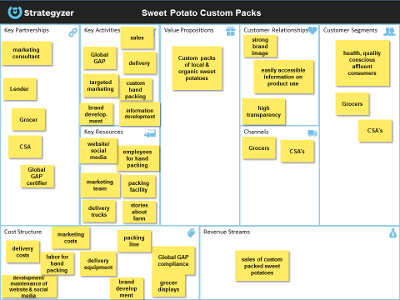
One of the appealing characteristics of the business model canvas is that discovery in working in one block may lead to changes in other blocks. Obviously, if the additional costs of this value-proposition exceed the additional revenues, then changes must be made. But the changes might be in Channels e.g. personal delivery may be very expensive so that another delivery option is considered. This might lead to different Key Resources being needed and new Key Partners investigated for delivery options, and so on. In other words the canvas is a living, working, dynamic document intended to facilitate discovery and adaptation in implementation of the business model.
Other business canvases for other value Propositions emerged from the teams. For example, another Value Proposition for the case study farm is producing very high quality tobacco to specifications set by tobacco manufacturers for the emerging innovation in heat-not-burn tobacco products. Another example, was planting and harvesting earlier soybeans to take better advantage of a high positive basis in North Carolina for early soybeans. We chose to illustrate the usefulness of the business canvas with a canvas for one value proposition, but a business model canvas can be developed to model the whole farm business. In fact the canvases developed by the class are more akin to a model for the whole farm. And, as noted, financial projections, changes in HR policies and management and labor needs flow out of the business model.
Another advantage to using the business model canvas to teach strategic planning is the farmers really enjoy this tactile learning process. Working in teams on the canvas stimulated excitement and sharing of ideas among the class. Evaluations by the class of the sessions on the business model canvas rated for applicability and interest were very high (4.4-4.6 on a scale of 1-5) with many comments like “group discussion was great” and “this pulled it all together so it started to make sense.” Feedback from the class is that they are already applying in their farm businesses some of the new business skills and intuition learned in the first week’s session.
The class will continue their work in teams on the business model canvas for the case study farm. During the summer the teaching team is working on further customizing the program to the needs of this specific class. This includes further development of the case study farm with input from the class. A team of 5 class members was chosen by their peers to work in between the sessions (via virtual meetings) on developing more information from IBM’s Watson for a more detailed PESTEL analysis on sweet potatoes and tobacco. This information will feed into refinement of the business model canvas. Evaluation of the impact of the program on farms will continue after the program concludes. In particular, evaluation of adoption and impact of changes in management practices will be conducted one year after completion of the program.
Conclusions
The business model canvas provides a lean, dynamic and flexible way to model the farm enterprise. Value Propositions for the farm business are formulated based on discovery of market opportunities in the Customer Segment and leverage of strengths in other parts of the business. Actions in other building blocks of the business model canvas flow from the value proposition. This approach to business modeling aids in discovery of new opportunities and the formulation of strategies to create value by facilitating change in the building blocks of the business model. Further, the business model canvas is a tactile learning process that is particularly effective for management education for farmers.
References
Blank, S. 2013. Lean Start-Up Changes Everything. Harvard Business Review 91(5):65-71.
Markham, S., and Mugge, P. 2015. Traversing the Valley of Death: A Practical Guide for Corporate Innovation Leaders. Innovation Press. U.S.A. 178 pages.
Osterwalder, A. and Pigneur, Y., 2010. Business Model Generation. John Wiley and Sons, Inc. U.S.A. 281 pages.
Osterwalder, A., Pigneur, Y., Bernarda, G., Smith, A., and Papadakos, P. 2014. Value PropositionDesign. John Wiley and Sons, Inc. U.S.A. 290 pages.
USDA. 2012 Census of Agriculture. Retrieved from www.agcensus.usda.gov.

